
NAME: MUDASSAR AHMAD

ROLL: SU92-BSDSM-S25-005

SUBJECT:AI(LAB)

SUBMITTED TO: SIR RASIKH

Table of Contents
Table of Contents 2
Introduction: 3
Objectives: 3
Tools and Technologies 3
Methodology / Working 3
Model Training 4
Evaluation Metrics 4
Code Implementation 5
Output 8
results 8
Line graph 9
Plot Graph 10
Discussion 10
8. Conclusion 10

AI LAB TASK # 12

Introduction:
In this lab, multiple machine learning classification models were applied to a dataset. The dataset was first preprocessed and then divided into training and testing sets. Different classifiers were trained and evaluated using performance metrics such as accuracy, precision, recall, and F1-score.
The purpose of this lab is to compare different models and determine which performs best

Objectives:
- To split dataset into input (X) and output (Y)
- To convert categorical data into numerical form
- To apply multiple classification algorithms
- To evaluate models using different metrics
- To compare performance using graphs

Tools and Technologies
- Python
- CSV Module
- File Handling

Methodology / Working
The program is divided into two classes:
1 Data Splitting (X and Y)
The dataset was divided into independent variables (X) and dependent variable (Y).
x = data.iloc[:, 0:-1]
y = data.iloc[:, -1]
Encoding Categorical Data
Categorical columns were converted into numerical form using factorization.
cat_columns = x.select_dtypes(['object']).columns
x[cat_columns] = x[cat_columns].apply(lambda col: pd.factorize(col)[0])
Train-Test Split
The dataset was divided into training and testing sets using a 70:30 ratio.
X_train, X_test, Y_train, Y_test = train_test_split(x, y, test_size=0.3, shuffle=False)

Model Training
The following classification models were applied:
- Bernoulli Naive Bayes
- Random Forest
- Gaussian Naive Bayes
- Decision Tree
- Multinomial Naive Bayes
- K-Nearest Neighbors
Each model was trained using training data and evaluated on test data.

Evaluation Metrics
The following metrics were used:
- Accuracy
- Precision
- Recall
- F1 Score

Code Implementation

import pandas as pd
data=pd.read_csv("insurance.csv")
display(data.head())
print("we have rows:{}".format(data.shape[0]),
"\n we have colunms:{}".format(data.shape[1]))
import numpy as np
display(data.isnull().sum())
np.sum(pd.isnull(data))
display(data["smoker"].unique())
display(data["age"].unique())
display(data["sex"].unique())
num=data['smoker'].mode()[0]
data['smoker']=data["smoker"].fillna(num)
display(data["smoker"])
display(data.info())
data['bmi'] = data.bmi.astype(np.int64)
display(data.info())
data.drop("region" ,axis=1,inplace=True)
display(data.head())
display(data.dtypes)
x=data.iloc[:,0:-1]
x.shape
y=data.iloc[:,-1]
y.shape
display(data.shape)
data['charges_category'] = pd.qcut(data['charges'], q=3, labels=['low', 'medium', 'high'])
y = data['charges_category']

print("Original 'charges' column head:")
display(data['charges'].head())
print("\nNew 'charges_category' column head and value counts:")
display(y.head())
display(y.value_counts())
c_columns=x.select_dtypes(['object']).columns
x[c_columns]=x[c_columns].apply(lambda x:pd.factorize(x)[0])
from sklearn.model_selection import train_test_split
X_train, X_test, Y_train, Y_test = train_test_split(x,y, test_size=0.3, shuffle=False)
import pandas as pd
import numpy as np
import matplotlib.pyplot as plt

from sklearn.model_selection import train_test_split
from sklearn import metrics

# Models
from sklearn.naive_bayes import BernoulliNB, GaussianNB, MultinomialNB
from sklearn.ensemble import RandomForestClassifier
from sklearn.tree import DecisionTreeClassifier
from sklearn.neighbors import KNeighborsClassifier
import pandas as pd
import numpy as np
import matplotlib.pyplot as plt

from sklearn.model_selection import train_test_split
from sklearn import metrics

# Models
from sklearn.naive_bayes import BernoulliNB, GaussianNB, MultinomialNB
from sklearn.ensemble import RandomForestClassifier # Changed to Classifier
from sklearn.tree import DecisionTreeClassifier # Changed to Classifier
from sklearn.neighbors import KNeighborsClassifier # Changed to Classifier

models = {
"BernoulliNB": BernoulliNB(),
"GaussianNB": GaussianNB(),
"MultinomialNB": MultinomialNB(),
"RandomForestClassifier": RandomForestClassifier(random_state=42),
"DecisionTreeClassifier": DecisionTreeClassifier(random_state=42),
"KNeighborsClassifier": KNeighborsClassifier()
}

results = {
"Accuracy": [],
"Precision": [],
"Recall": [],
"F1": []
}

model_names = []

for name, model in models.items():
model.fit(X_train, Y_train)
y_pred = model.predict(X_test)

acc = metrics.accuracy_score(Y_test, y_pred)
prec = metrics.precision_score(Y_test, y_pred, average='weighted', zero_division=0)
rec = metrics.recall_score(Y_test, y_pred, average='weighted', zero_division=0)
f1 = metrics.f1_score(Y_test, y_pred, average='weighted', zero_division=0)

print(f"\n{name} Results:")
print(f"Accuracy: {acc:.4f}")
print(f"Precision: {prec:.4f}")
print(f"Recall: {rec:.4f}")
print(f"F1 Score: {f1:.4f}")

model_names.append(name)
results["Accuracy"].append(acc)
results["Precision"].append(prec)
results["Recall"].append(rec)
results["F1"].append(f1)

# Optional: Display results in a DataFrame
# results_df = pd.DataFrame(results, index=model_names)
# display(results_df)
# Plotting Line Graph Showcasing all the Scores of applied Classifiers
plt.figure(figsize=(16,10))

x_labels = model_names # Use the model names from the previous execution

plt.plot(x_labels, results['Accuracy'], marker = 'o', label='Accuracy')
plt.plot(x_labels, results['Precision'], marker = 'o', label='Precision')
plt.plot(x_labels, results['Recall'], marker = 'o', label='Recall')
plt.plot(x_labels, results['F1'], marker = 'o', label='F1')

plt.title("Scores of Applied Classifiers")
plt.xlabel("Classifier Models")
plt.ylabel("Score")
plt.legend()
plt.grid(True)
plt.show()
left = [1, 2, 3, 4, 5, 6]
plt.figure(figsize=(16,10))
# heights of bars
height = results['F1'] # Use F1 scores from the results dictionary
# labels for bars
tick_label = model_names # Use the model names from the previous execution
# plotting a bar chart
plt.bar(left, height, tick_label = tick_label, width = 0.9, color = ['#08737f', '#00898a', '#089f8f', '#39b48e', '#64c987',
'#92dc7e'])
# naming the x-axis
plt.xlabel('Classifiers')
# naming the y-axis
plt.ylabel('F1 Scores')
# plot title
plt.title('F1 Scores of Applied Classifiers')
# function to show the plot
plt.show()

Output
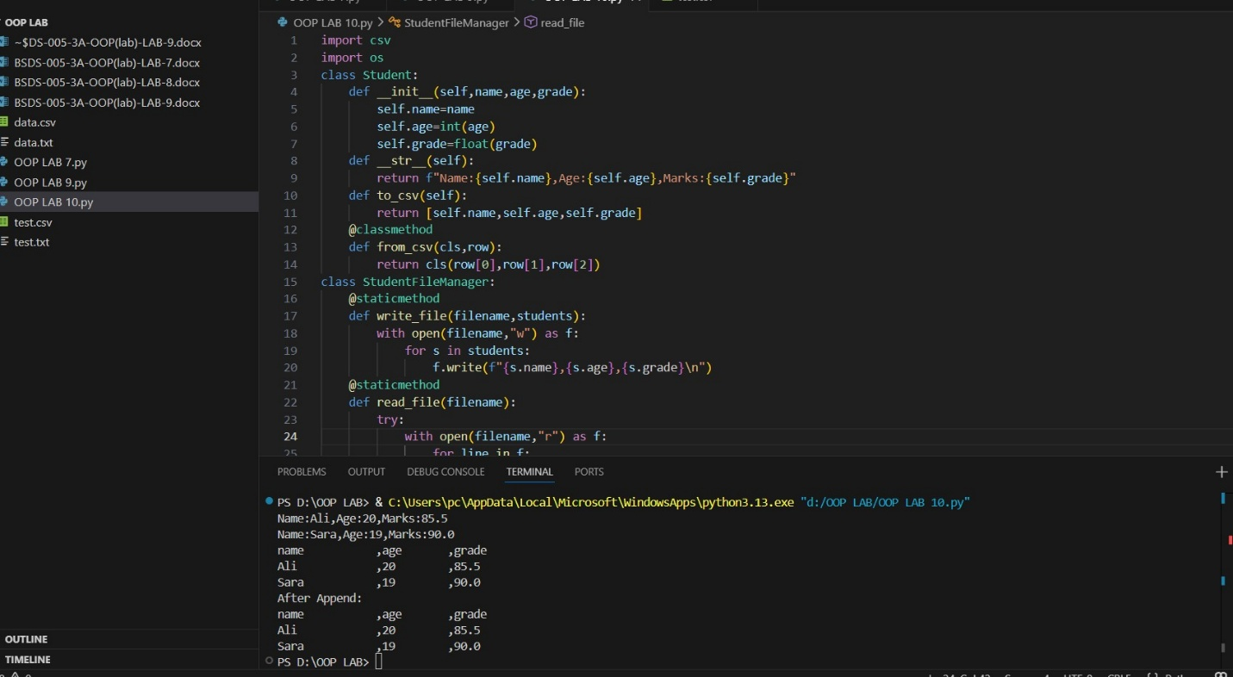

results
- All models were successfully trained and tested
- Performance metrics were calculated for each model
- Graphs clearly show comparison between models
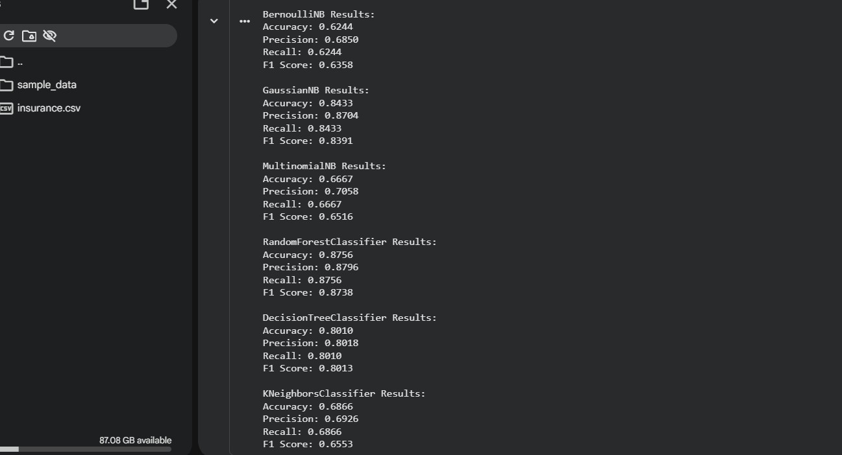

Line graph
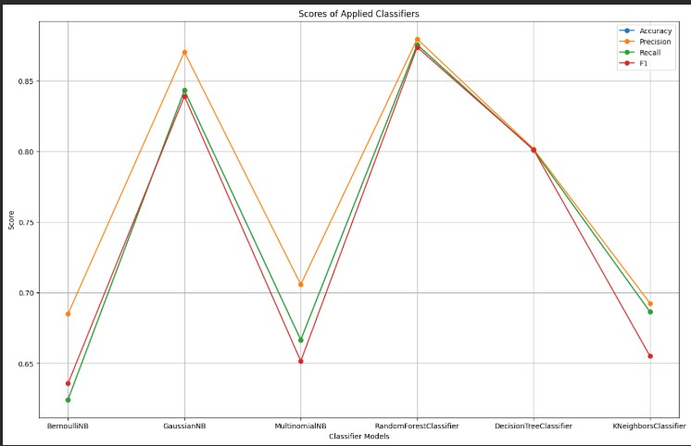

Plot Graph
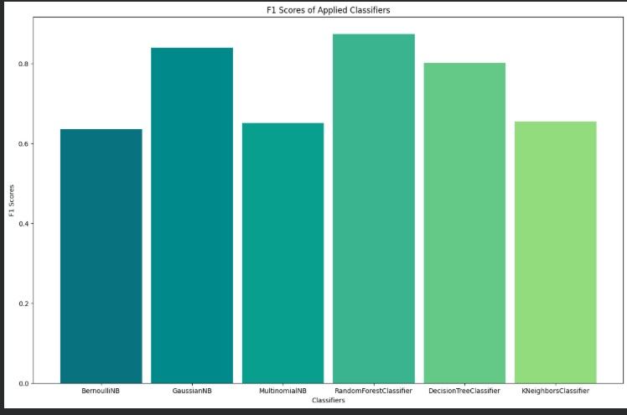

Discussion
- Different models show different performance levels
- Some models perform better depending on data
- F1 score helps in balanced evaluation

8. Conclusion
In this lab, multiple classifiers were applied and compared successfully. The results show that model performance varies, and selecting the right model is important for accurate predictions.

